**Appendix F. Screencast of Steps Involved in Model Preparation**

# **Adding the data**

Make sure spatial extension is on.   
Overwrite is enabled. ArcHydro and HEC-GeoHMS tool are loaded.

Add the following data (DEM and Stream data first)

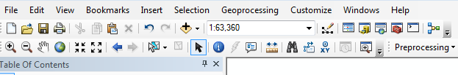

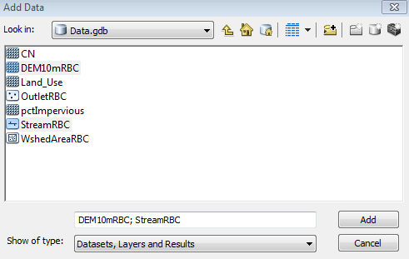

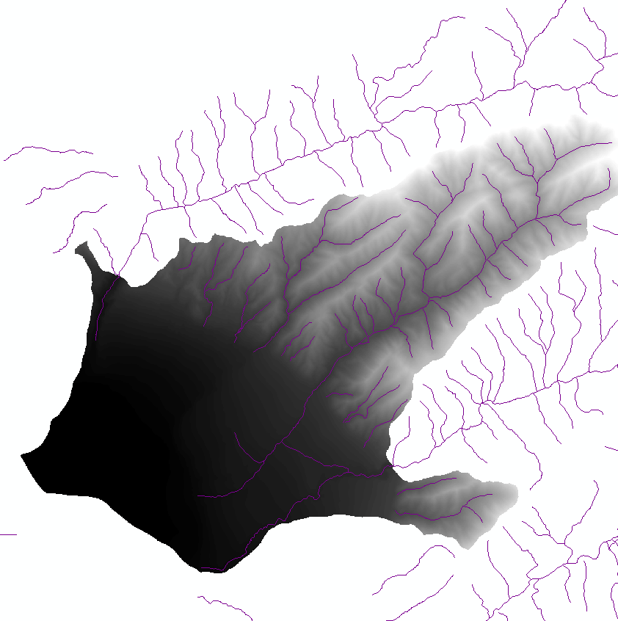

# **Terrain Processing (Using ArcHydro)**

Go through the step one through 9 in the *Terrain Processing* tab in the Arc Hydro toolbar.

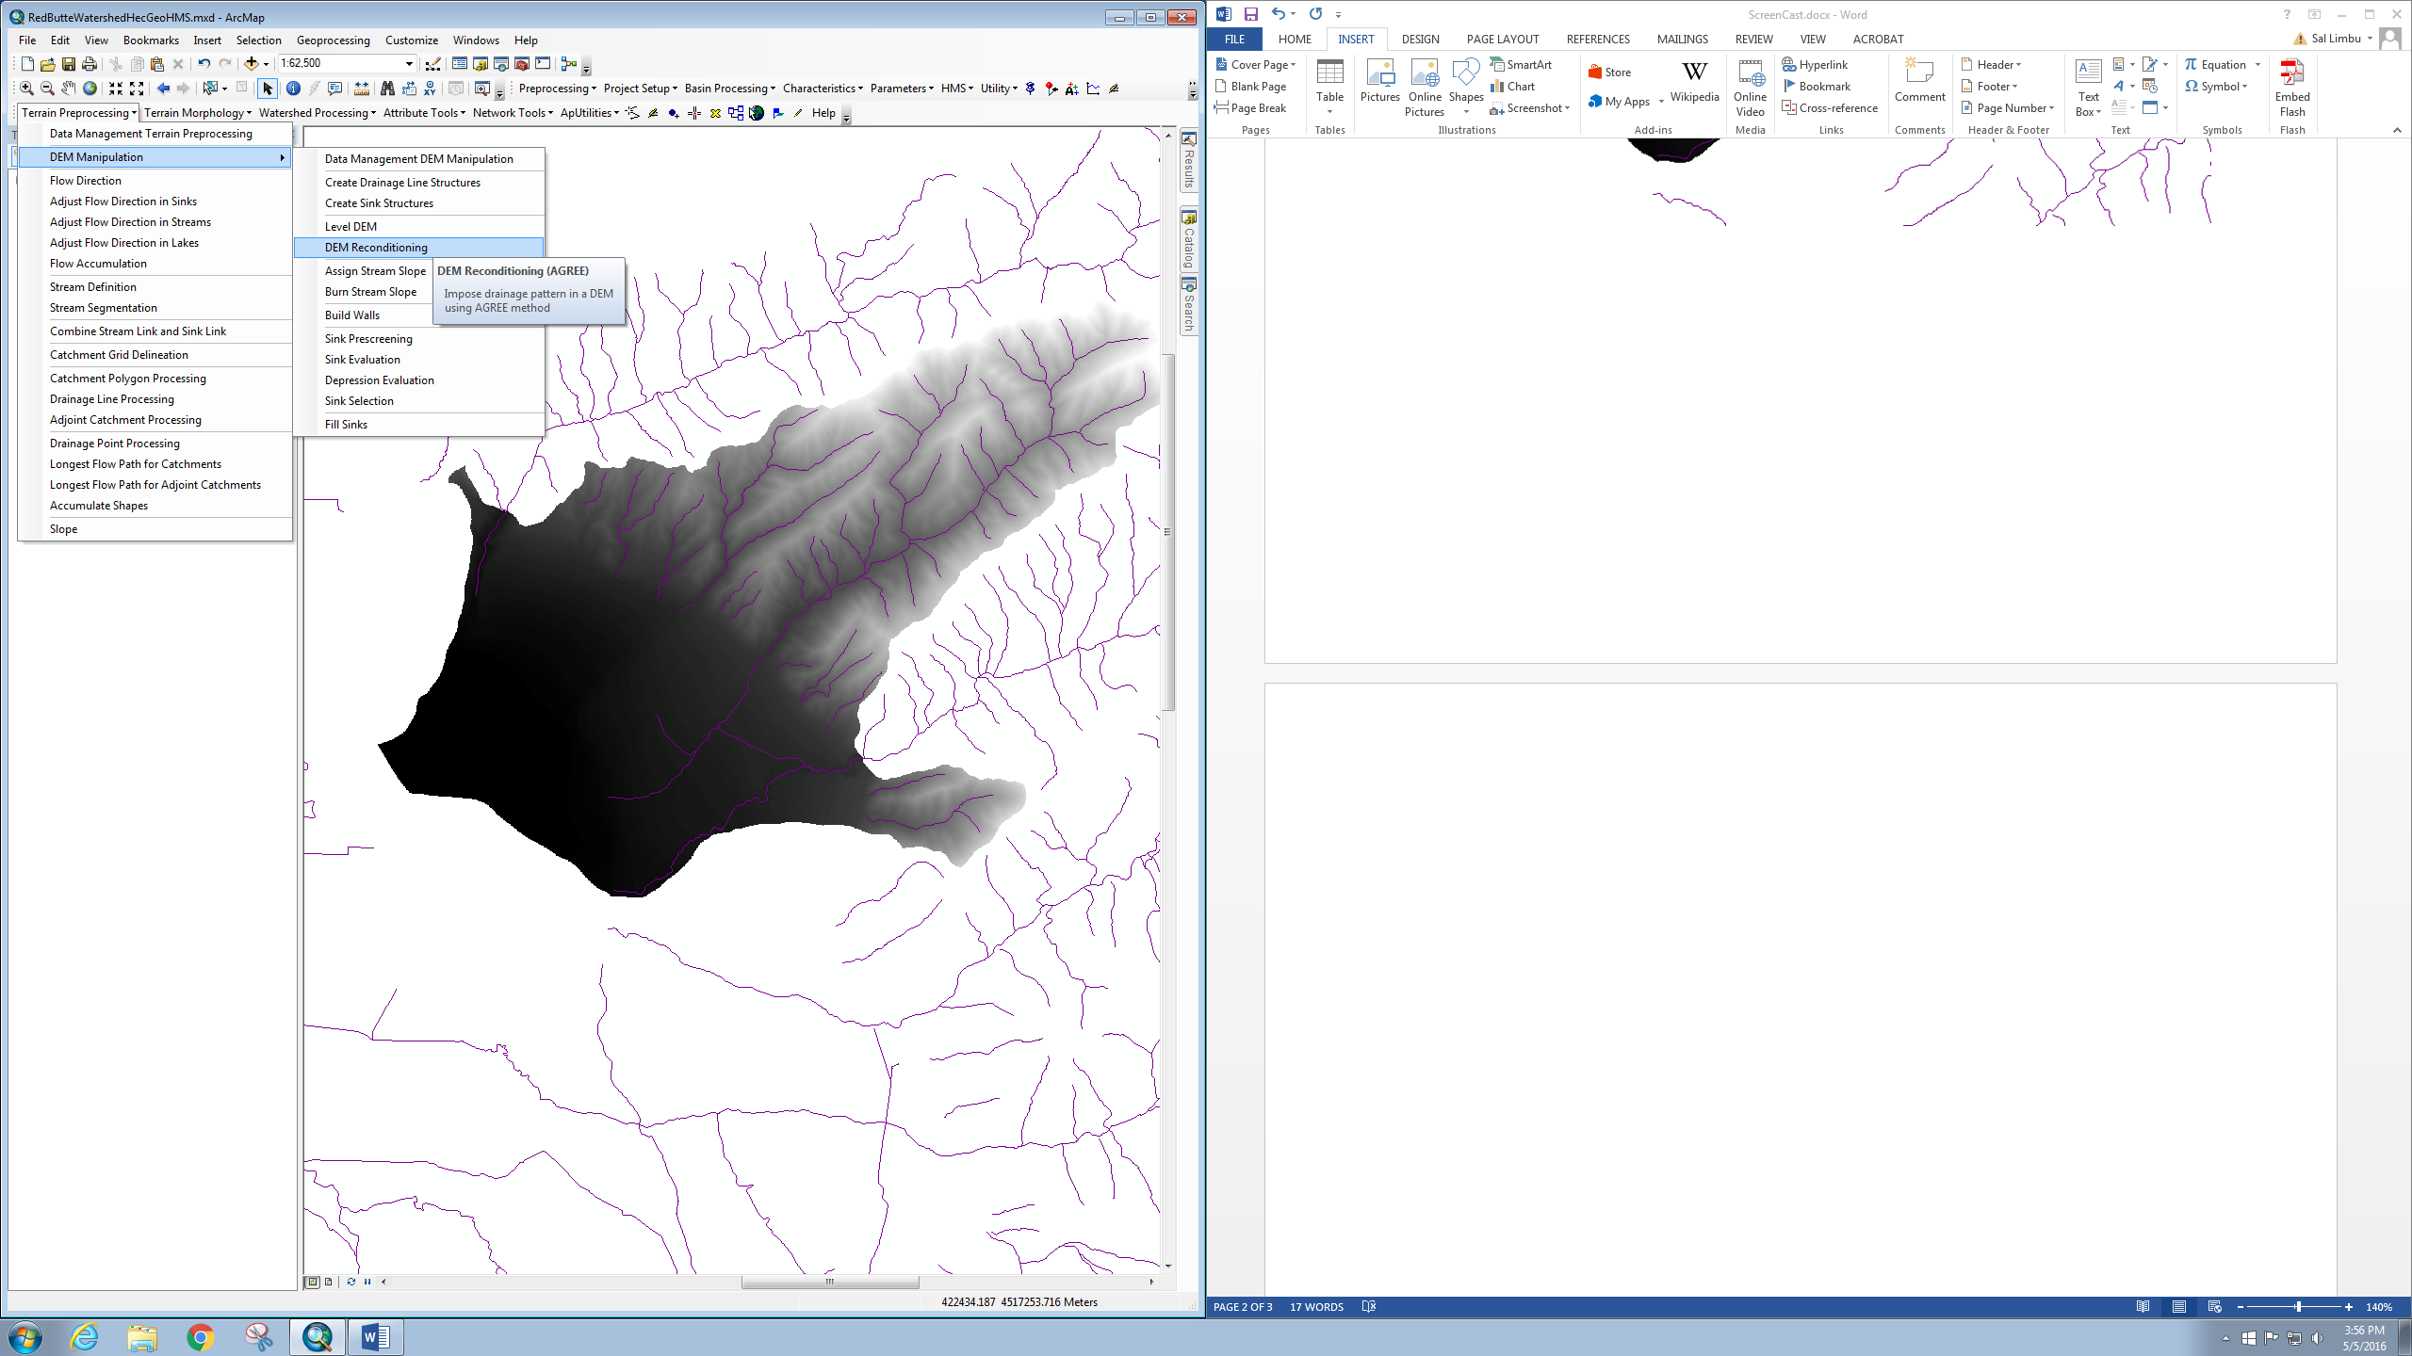

1

2

3

4

5

6

7

8

9

While going through the steps, accept default recommended filenames and parameter values. However, it’s a good idea to see each file created, just to make sure the files are not empty or incomplete. One two steps, changes other than the recommended values are preferred.

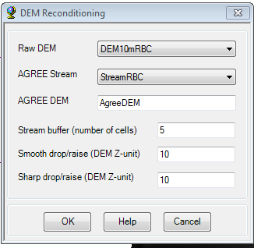During *DEM reconditioning*, the Sharp Drop / Rise value = 10 is preferred, where as other values could be left to default.

Similarly, during the Stream definition process, the value of Area should be 1 square km. Actually, this value is very small for usual watershed, however, Red Butte Creek watershed is small so this makes sense for small watershed such as Red Butte Creek.

**Terrain Processing > Stream Definition (**Area = 1 km2 (because small watershed) )

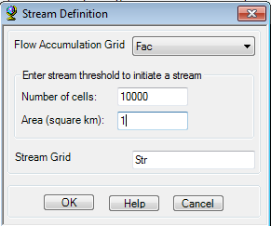

# **HEC-GeoHMS**

Open up the HEC-GeoHMS toolbar, and start a new project. Accept default names or name the project, and then describe it and add some metadata related to the project.

**Project Setup > Start New Project**

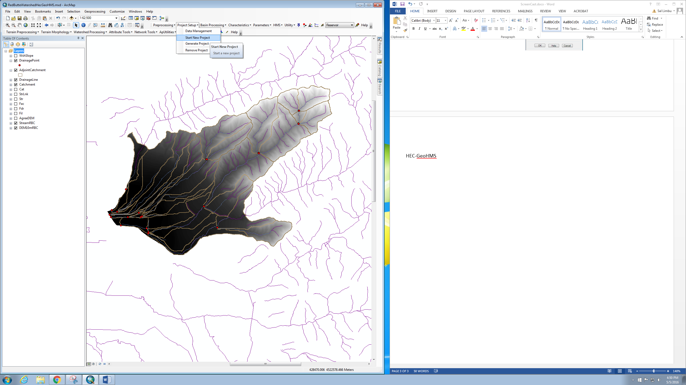

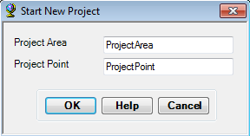

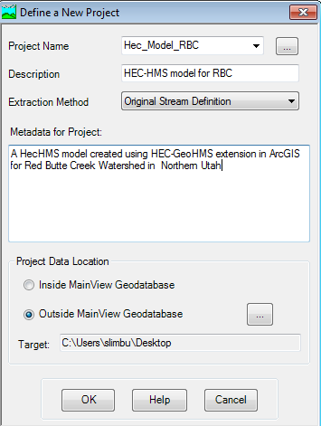

Add the outlet point shapefile, which is not essential to create HEC-HMS model, but nice to know exactly where the outlet is.

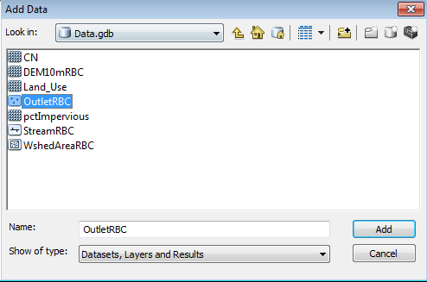

Change symbology of the point to something that is easily recognizable, or that represents the outlet.

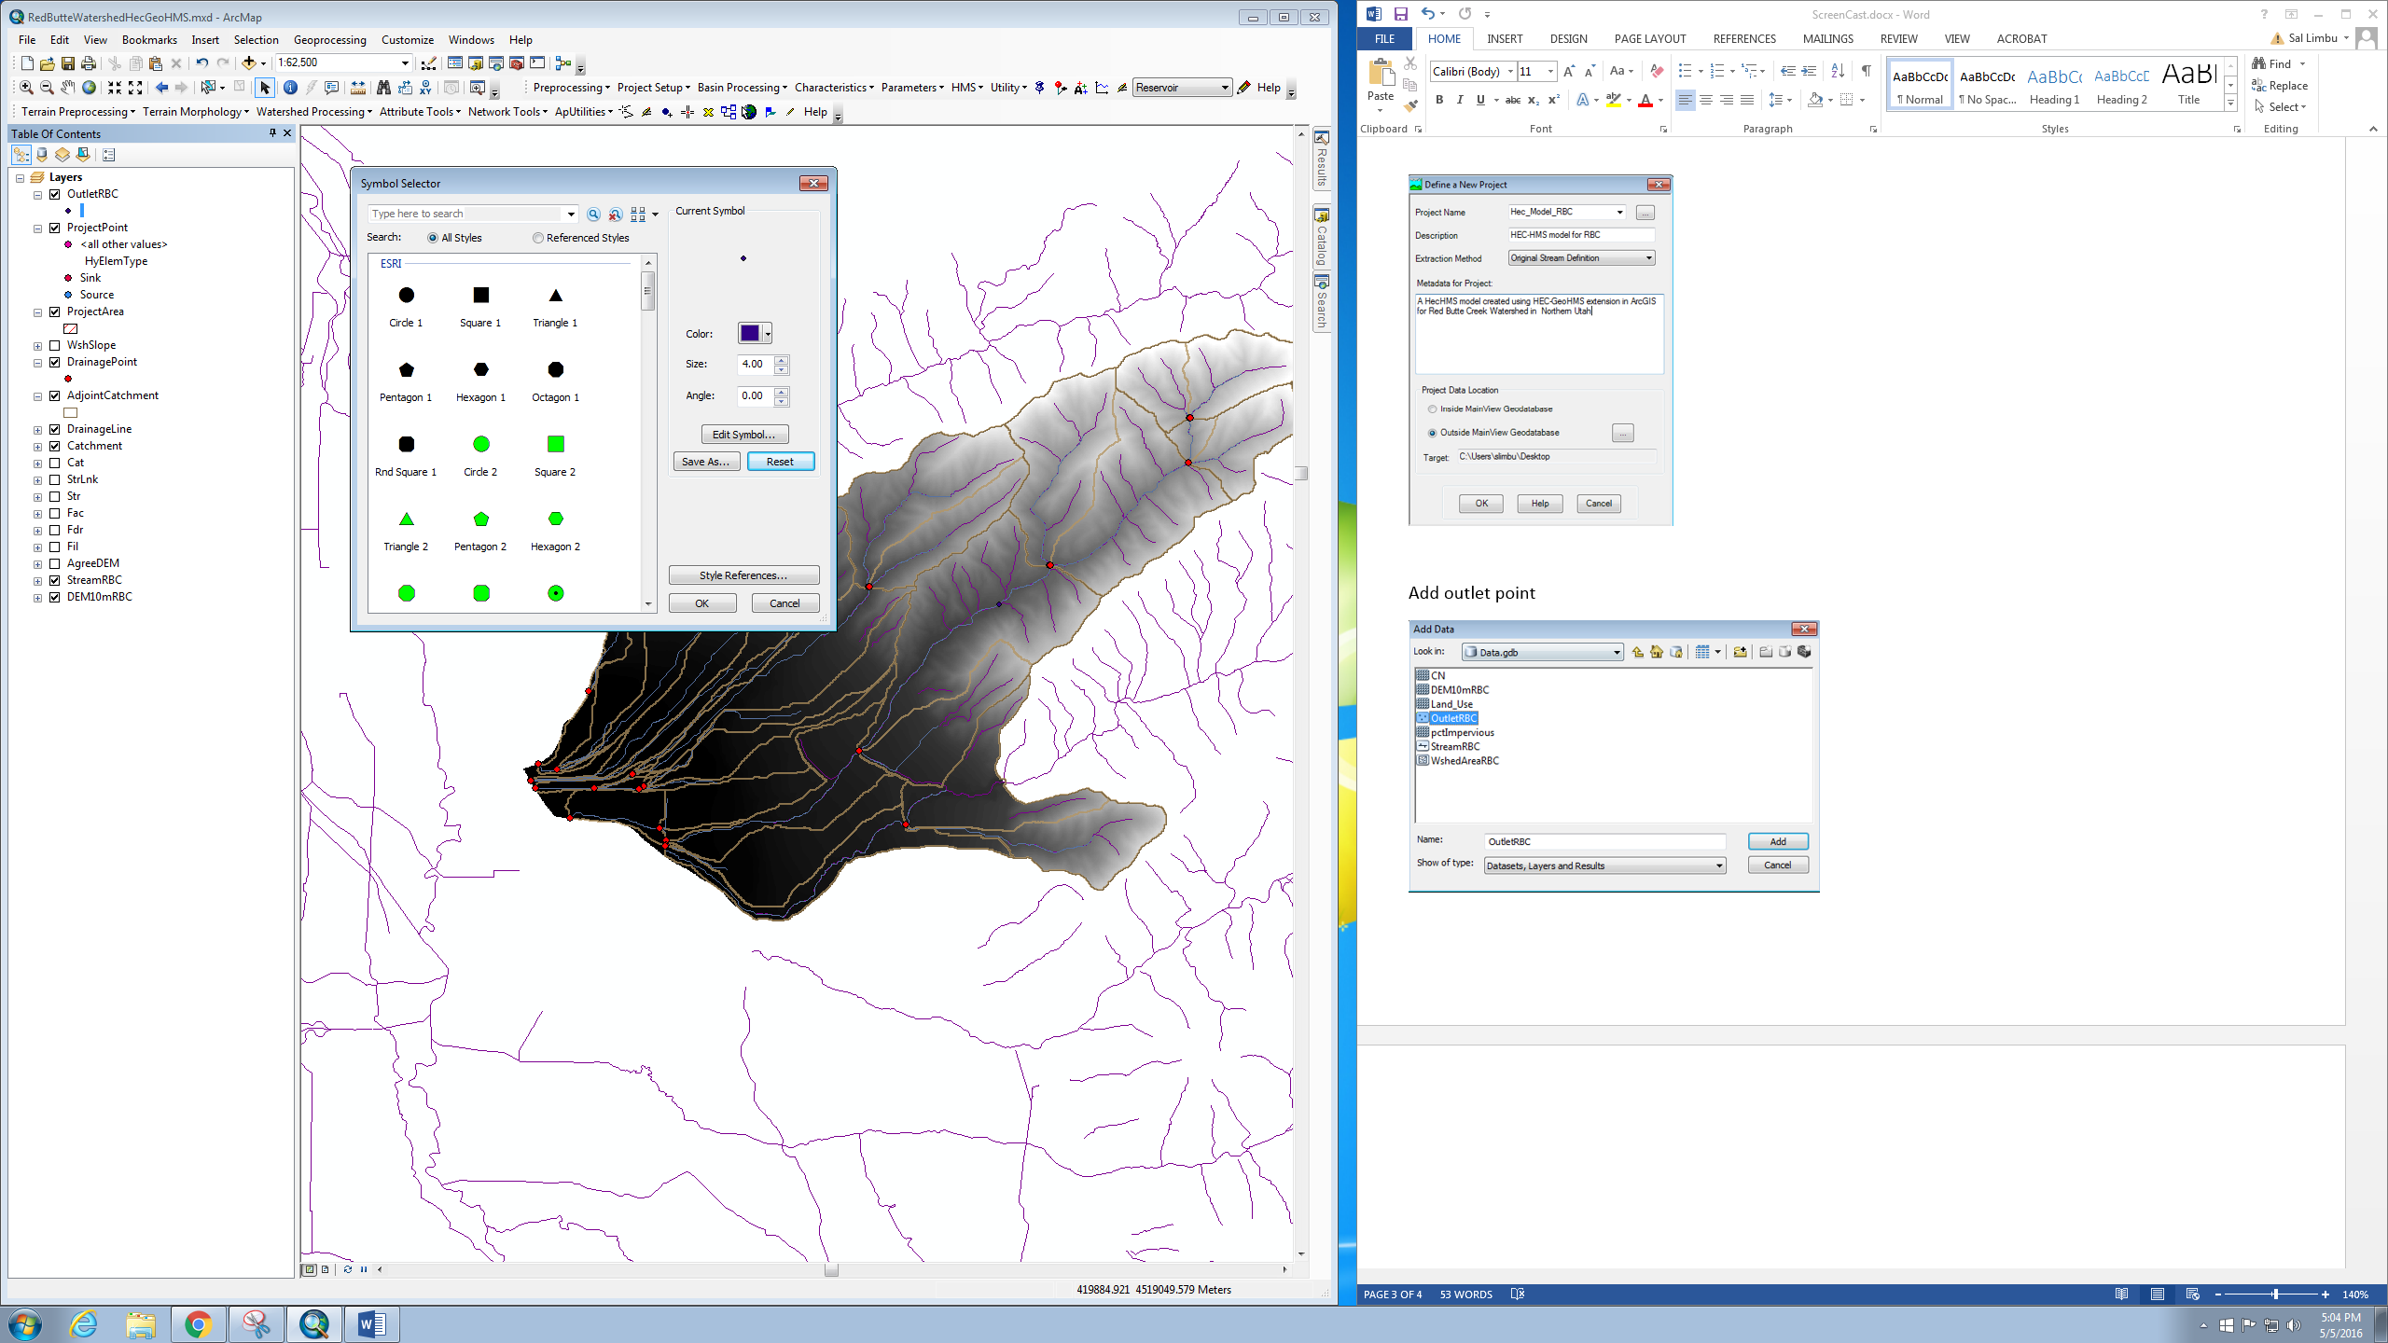

Add project point, very close to the outlet point just added



Click on stream, very close to the outlet > Click OK

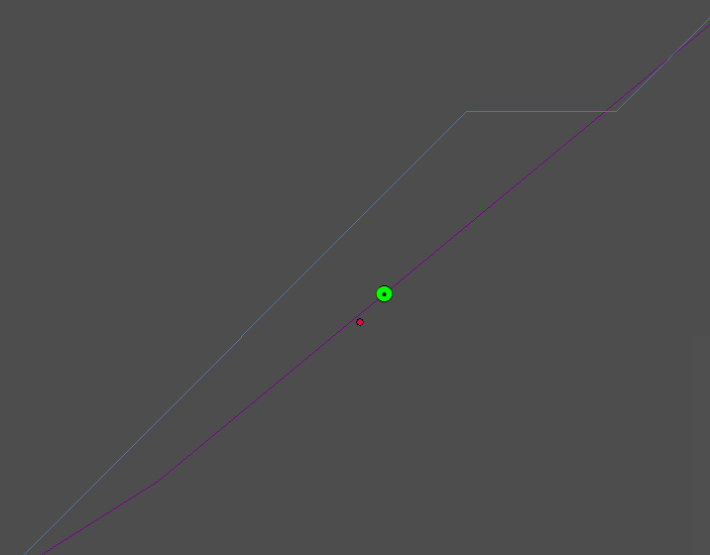

**Project Setup > Generate project > Yes**



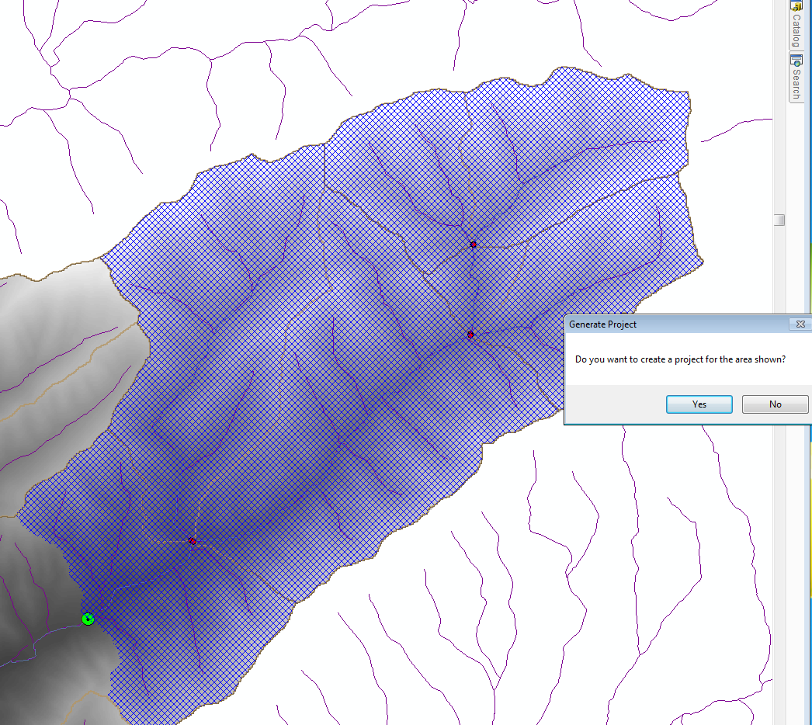

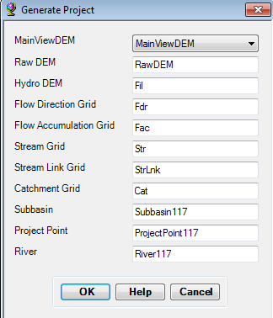

The suffices (number) that come after the subbasin or project Point name or River name does not make any difference. Leave them to blank.

Once the Project is generated, the layers in the Table of Content in ArcGIS will start getting populated, and it will end up with one dataframe added on the Map document open.

***Note*:** We can skip the Basin Processing for this Model, since there are no subbasins or rivers that needs merging.

**Basin Characteristics**

This section helps add basin characteristics into the subbasin and the river file created for the project area. In this section, you go through all the steps in the *Characteristics* tab of the Hec-GeoHMS extension. Accept the default values for all the steps. Each step in this section updates the attribute table, and / or creates news shapefile.

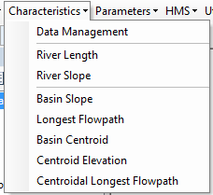

1

2

**NOTE**: On certain HEC-GeoHMS versions, these steps do not work, or sometimes do not add the results to the display. A function that has not run correctly will be marked as error, and displayed in red square error bubble in the lower left part of the screen. If there is any error, it is important to do the same step again, which is all that it takes to solve the problem. In other cases, manual entry to the subbasin or river attribute table might be necessary.

**Parameters:**

First, we need to select the HMS processes. Then autname basins and rivers.

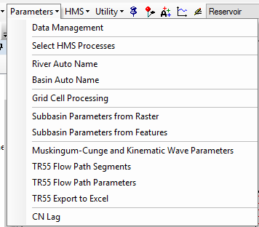

1

2

Add the CN grid for the area, which is a 30m resolution raster file containing CN value for each cell in the watershed. After that, add **Parameter > CN Lag.**

## HMS:

On the HMS section, follow through the steps 1 through 6, as shown below. Select the default entry, but make sure the files are correctly assigned. Also, if a certain function is not executed, retry should be able to do. If that does not solve the problem, forced writing of attribute table might be needed. Also, at times, the newly created files may not add automatically to the display. In those cases, those files must be added manually.

HMS > Map to HMS Units > English Units

HMS > Check Data > OK

Select HMS / HMS Schematic > OK

HMS > Toggle HMS Legend  > HMS Legend

HMS > Add Coordinates

HMS > Prepare Data for Model Export > OK

HMS > Background Shape File > OK

HMS > Basin Model File > OK

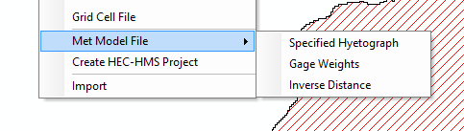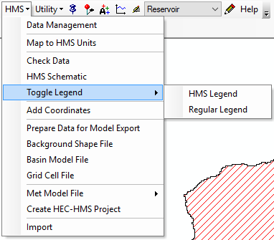

1

2

3

4

5

6

The **HMS> Prepare Data** for Model Export creates empty basin file.

The funciton **HMS>Met Model File > Specified Hyetograph** creates basin and gage files.

Browse those files give a new name to the output HMS file to be created in the last step in HMS tab, the create HEC-HMS project. The timing of simulation start and end does not matter, neither does the hyetograph files. These can be (and will have to be) changed from HEC-MODEL itself.

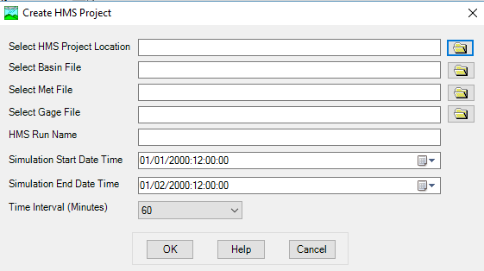

The file named in the **HMS Run Name** tab here will be the HMS file that is created. Changes in HMS is required, after which the model is ready for calibration.